2021
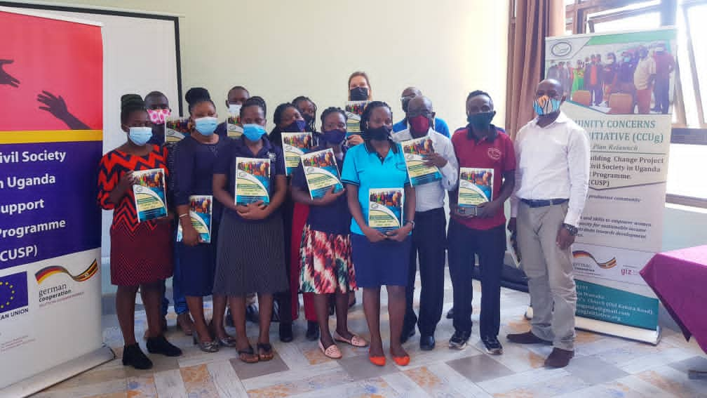
Annual Report

Community Concerns Uganda Initiative (CCUg)
Email: concernsuganda@gmail.com
Website: http://ccuginitiative.org
P.O. BOX 196, Jinja

Acknowledgement
Community Concerns Uganda Initiative (CCUg) greatly appreciates the entire team for the great work delivered during the year 2021. This has been a tough year during which the team grappled with the effects of the COVID-19 pandemic.
We are indeed thankful to our partners and donors who have provided funding for the projects to be implemented. Your continued support makes all of our work possible, and on behalf of the CCUg staff and the women and children we serve, we thank you very much for your generosity and pray that you will keep up with the spirit of giving.
We thank the Executive Board of Trustees (BOT) for the advice and follow-up on our work; we are indeed grateful. Not forgetting the members that engage with us throughout the year, thank you for being available and allowing us to serve you.

Message from the Chairperson
On behalf of the Board of Trustees (BOT) we extend our sincere gratitude to our dear friends, partners, and donors for the journey you have taken with us this year 2021. Great thanks to the Almighty God who has enabled us to sail through this very difficult year with good health.
We extend our gratitude to our staff who continued working in the midst of the COVID-19 lockdown restrictions making sure that services reached the beneficiary communities. The achievements we registered despite the challenges posed by the pandemic are a testimony to the industriousness and dedication of our staff to serving the community.
Special thanks go to our partners and donors, especially Amplify Change, EU – Can Aid, Elevate partners for Education and the Local governments for the invaluable support without which it would have been difficult to score the successes CCUg has registered this far.
We pray and look forward to even more success in the coming year 2022!

Warm regards,

Dr. Nabongo Patrick
Chairman Board of Trustees

Message from the Managing Director
On behalf of CCUg I thank God who has enabled us to come to the end of 2021 and to register great achievements. I thank Him for the gift of life amidst the COVID-19 pandemic that has taken many lives. He has kept us and you. He has also blessed us with funding to be able to extend our services to the communities where we are serving.
I would like to thank our Consultative Panel, the Senior Advisor and international Partnership Coordinator who support us greatly without getting tired, our Board of Trustees who are always there to guide us, and donors who funded our projects to put a smile on all those we serve, partners and friends. We are indeed grateful.
I would like to thank Amplify Change, GIZ, EU- Can Aid, Elevate Partners for Education, Global Giving, Giving Way, and all individual donors for all the funding for 2021. We were able to serve because you entrusted us with your funds. We hope that this partnership continues to grow bigger to better serve our community in the coming year.
I thank so much the entire CCUg team for working tirelessly to see that people’s lives change.
It is in this spirit of accountability that I present CCUg’s 2021 Annual Report.
With warm regards,
Nakirya Brenda Doreen

Table of Contents
Acknowledgement
Message from the Chairperson ii
Message from the Managing Director iii
Table of Contents iv
List of Abbreviations v
Background 1
Approaches 1
Project/Program Updates 2
Organizational Capacity Building 2
Achievements 2
Pictorial Collage of Capacity Building Activities 3
EDUCATION 4
Achievements 4
Challenges 4
Vocational Skilling 5
WASH, SRHR and Mental Health 6
Achievements 7
Stories of Change 10
Story 1: SMC Member, Wabulungu Primary School 10
Menstrual Health and Hygiene (MHH) 10
Raising Voices against Sexual Violence 12
Livelihoods 19
Group Savings Project 19
Growth trend of GSP Members from 2019 to 2021 20
Growth Trend of GSP Savings, Loans and Interest – 2019 to 2021 20
Challenges 21
OVERALL LESSONS LEARNT IN 2021 22
OVERALL RECOMMENDATIONS 22
FINANCIAL REPORT FOR 2021 23

List of Abbreviations
CCUg Community Concerns Uganda Initiative
BOT Board of Trustees
NGO Non-Government Organisation
OVC Orphans and Vulnerable Children
MHHM Menstrual Hygiene Health Management
GSP Group Saving project
SRGBV Sexual Gender-Based Violence
IEC Information Education and Communication Materials
IPTG Interpersonal Group Therapy
VLSA Village Saving and Loan Association
SRHR Sexual Reproductive Health and Rights
LC Local Council

Background
Community Concerns Uganda Initiative (CCUg) is a legally-registered Non-Government Organization (NGO) operating in the Busoga Sub-region, specifically in Jinja, Mayuge, Luuka, Buyende, and Kamuli Districts. Our offices are located in Wairaka at Old Kakira Road opposite St. Peter’s Church, Jinja District. We envision an educated, healthy and productive community free from poverty. Our mission is to provide education and skills to empower women and girls to acquire the capacity for sustainable income generation and to contribute to the development of their communities. CCUg is governed by a Board of Trustees and an Advisory Committee who provide supervisory support, guidance and direction to support the organization to achieve its goals. In 2021 we had a 12-member staff team, ten of whom were full-time and two part-time. Their service is having a great impact on the lives of many people in the communities we serve, as explained later in this report.
Strategic Objectives
- To promote hygiene and increase utilization of SRHR and mental health services in schools.
- To empower women and girls, including vulnerable children, through literacy development.
- To provide sustainable livelihoods for women and girls through vocational services and saving and credit schemes.
- To reduce gender-based violence among women and girls.
- To develop and strengthen the institutional capacity of CCUg.
Programme Areas
CCUg programs fall under the four major themes listed below shown with their associated active projects in 2021:
- Education – including OVC Sponsorship and Literacy Development
Orphans and Vulnerable Children (OVC) Sponsorship Project
Positive Deviance (Education)
- Health – including WASH, SRHR, and Mental Health
Menstrual Hygiene Management (MHM)
Raising Voices against Sexual Violence
- Sustainable Livelihood
Group Savings (GSP)
Adult Literacy
- Gender-Based Violence
School-Related Gender-Based Violence (SRGBV) ,
Our funding comes largely from grants and donations.

Approaches
Our method of work involves conducting high-quality, relevant research projects in the local communities we serve. The results of these studies inform the development of specific programs to address the needs revealed by the studies. The projects CCUg designs are delivered through sustainable, community-based interaction in one-on-one and group settings, and typically include a mix of classroom-style instruction, skills training and the delivery of material resources as needed to assist beneficiaries in establishing self-sustaining income-generating activities.

Project/Program Updates
This report mainly presents achievements, challenges, and recommendations regarding these projects. We begin with a look at the organizational Capacity Building training we undertook in early 2021. The goal of this training was to identify infrastructure and funding needs within the organization necessary to build on our successes and continue to grow the organization in the future.

ORGANIZATIONAL CAPACITY BUILDING
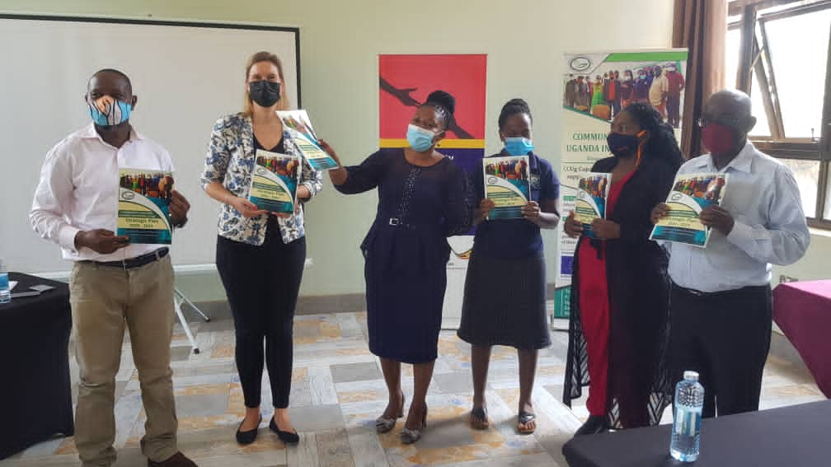
GIZ staff and CCUg board during the launch of the Resource Mobilization strategy

Achievements
- A 5-year Strategic Plan for Community Concerns Uganda Initiative was reviewed with the participation of all staff members and Board members and was subsequently approved by the Board of Trustees.
- In addition, a resource mobilization strategy was developed with the participation of all staff and Board members.
- Furthermore, a Board manual was developed with the participation of all staff and Board members.
- Later, CCUg staff and Board members were oriented on utilization of the Board Manual and Resource Mobilization Strategy. Further training was provided on Monitoring and Evaluation (M&E), which covered areas like M&E plan, Theory of Change, Output and Outcome Indicators, Project Management Cycle, Activity Plans and Reports, and tools for M&E. This will enable us to document, measure and report on our key successes or failures in implementation. Staff and Board received certificates after completion of this training. All these were conducted with support from the Civil Society in Uganda Support Programme (CUSP) which was implemented by the Deutsche Gesellschaft Fur Internationale Zusammenarbeit (GIZ) GmbH with financial support from the European Union.
- As part of Capacity Building, CCUg staff were provided with various training opportunities that have enabled them to improve skills in resource mobilization, monitoring, and evaluation, advocacy, governance, and proposal writing.

Pictorial Collage of Capacity Building Activities

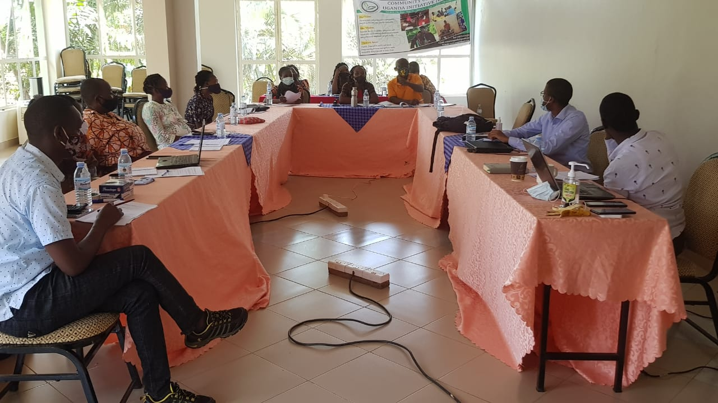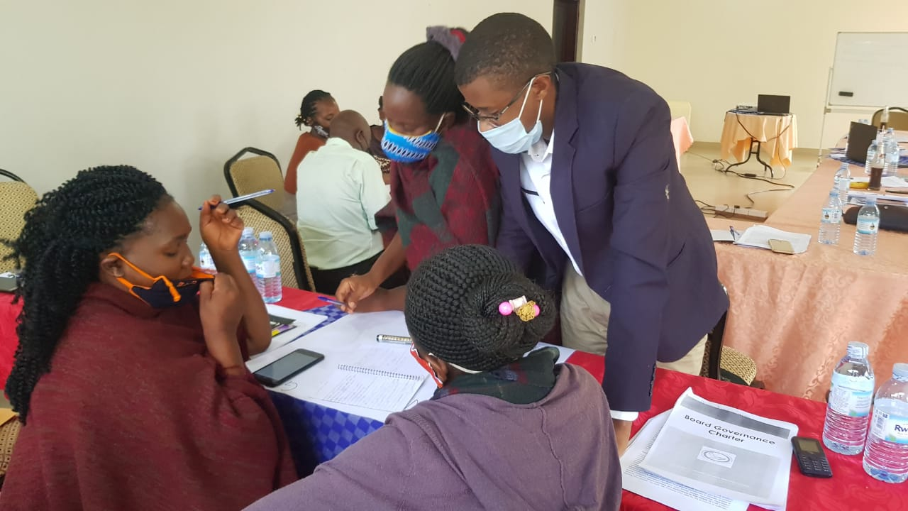
During Capacity Building

EDUCATION
Under this theme, we emphasize improving access to quality education and vocational skills – especially among socially and economically disadvantaged children and women. In 2021, we implemented 2 programs and 2 projects under this theme. These included Vocational Skills Training programs and Positive Deviance Projects. Due to COVID-19, students didn’t attend school for most of the year; they only went to school for one month. We gave them support by monitoring them and supporting them in their remote studies.
Positive Deviance
CCUg had a partnership with Elevate partners for Education in which we conducted remote surveys and conducted twelve radio talk shows.

Achievements
- We conducted phone interviews with 30 head teachers to assess the impact of COVID-19 on education.
- We conducted WhatsApp group engagements with head teachers from 10 schools in Mayuge District to share ideas on how to manage education during the COVID-19 lockdown. Participating schools were Bute Primary School, Buwolya Primary School, Bwiwula Primary School, Sagitu Primary School, Bukatabira Primary school, Bwondha Primary School, St Barbra Namadhi Primary School, Mayuge town Council Primary School, Maina Primary School, and Wamulongo Primary School.
- Our Managing Director moderated twelve one-hour talk shows on a local radio station (Busoga One 90.6 FM) in Jinja. These talk shows addressed different topics related to education, including strategies for remote learning, managing children’s behaviours, child labour, how schools/teachers can support remote learning, and the situation in households during the COVID-19 pandemic.

Challenges
- The one hour allocated for the talk show was not enough to fully cover all of the information that needed to be delivered.
- Most of the female parents represented on the talk shows could not openly express their views due to social anxiety related to being heard on-air, especially since this was a first-time experience for them.

VOCATIONAL SKILLING

Achievements
- We enrolled a total of twenty-one adult learners who are school dropouts. Twelve will study hairdressing and 9 will learn tailoring.
- Twelve adult learners were assessed in mathematics and English before the commencement of actual studies.

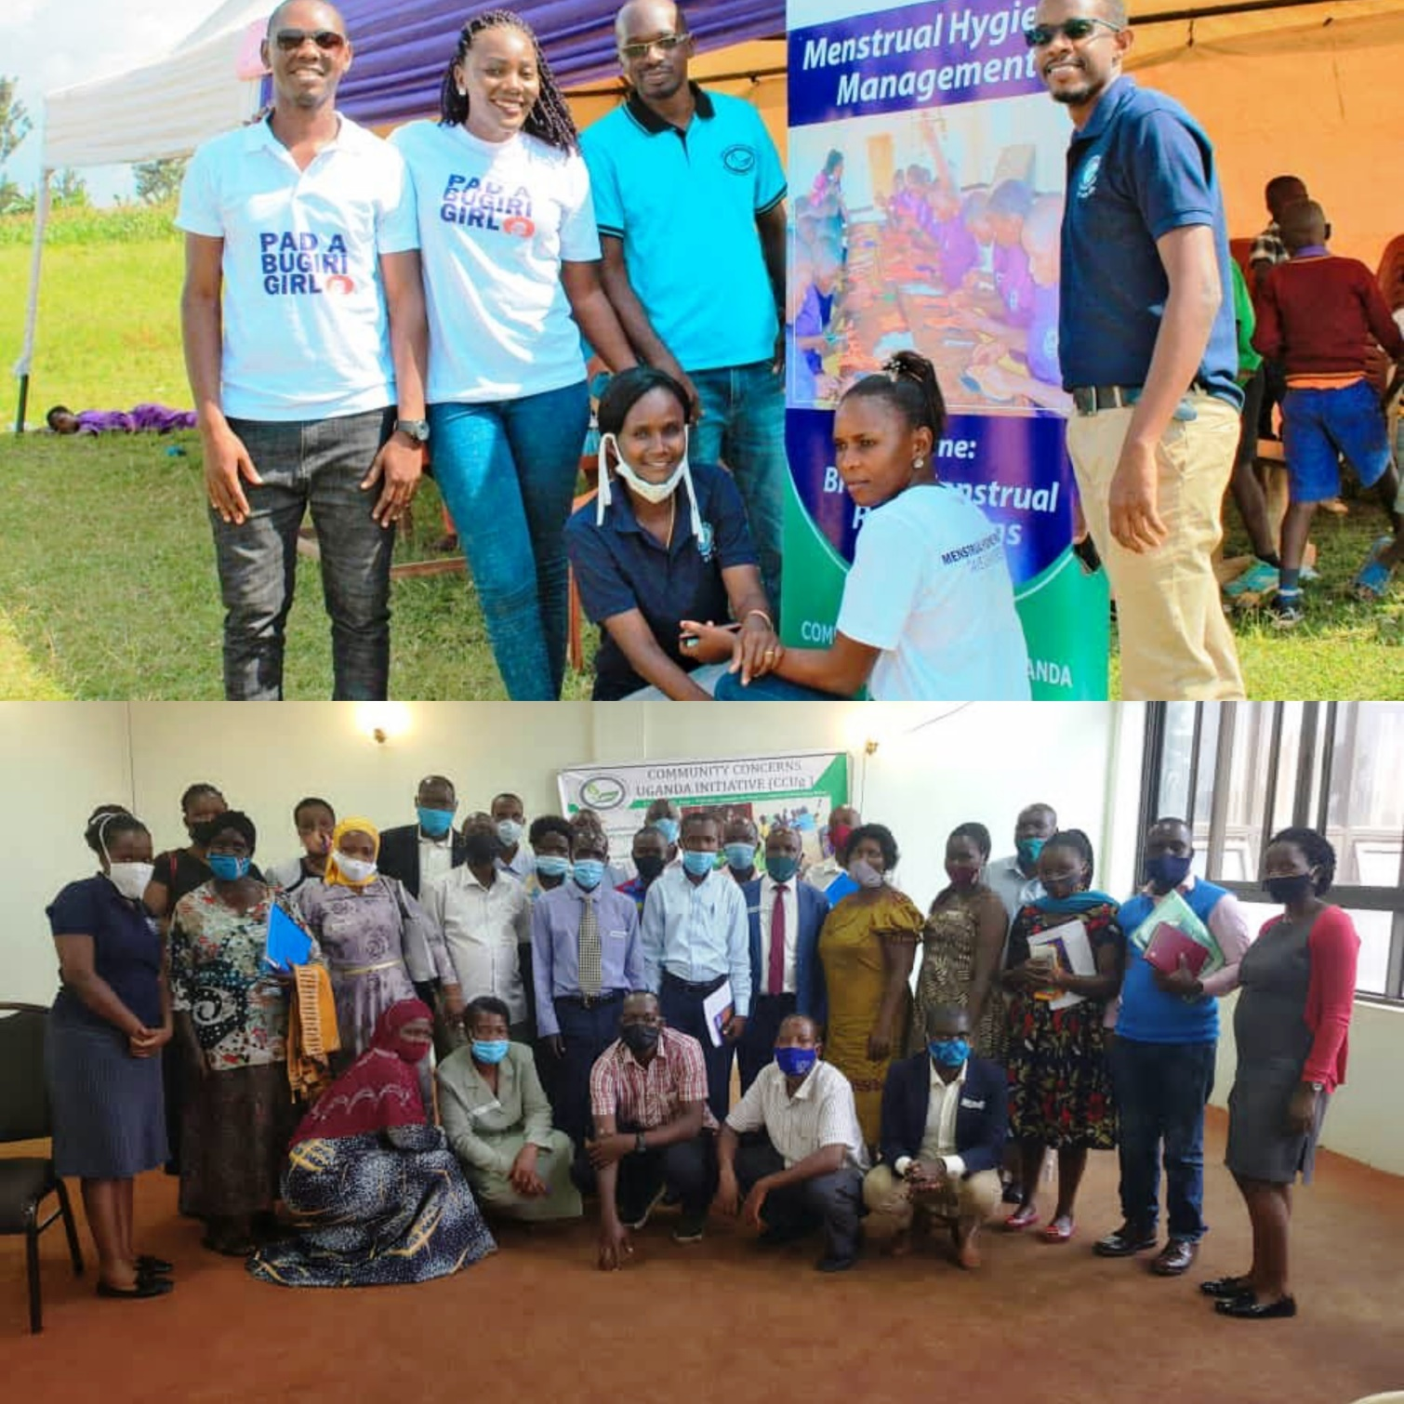
HEALTH

Under this theme, we conducted activities related to WASH and Sexual Reproductive Health and Rights (SRHR). We also had activities relating to Menstrual Health and Hygiene, WASH facility construction (WASH) and sexual violence (SRHR)

WASH
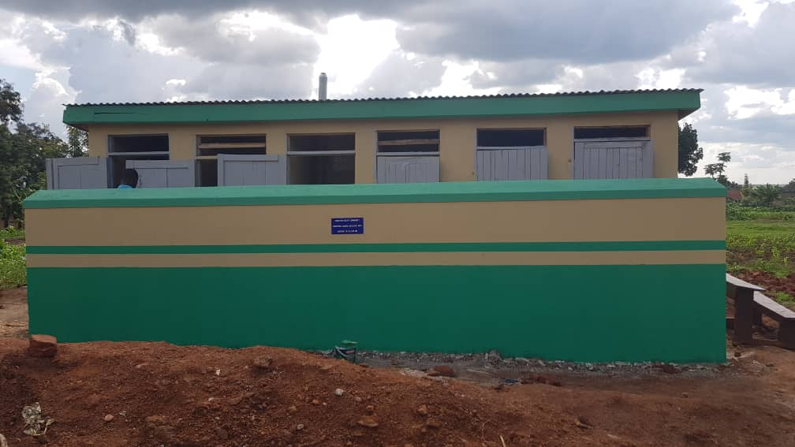
With support from Eu Can Aid!, CCUg initiated a WASH project in 2 rural primary schools in Mayuge district. The main project objective was to strengthen school health and learning through better sanitation and hygiene. The project integrates WASH facility construction, community collaboration, capacity building, and life skills-based hygiene education to improve the health and learning of over 2,000 pupils, teachers and other community members in Mugeya Primary School in Baitambogwe Sub-County and in Wabulungu Primary Schools in Magamaga Town Board, Mayuge district.

Achievements
- We had an inception meeting with the administrators of the school and members of the Parents, Teachers Association (PTA), and also the School Management Committees (SMC). The inception meetings provided details about the project and its activities and sought support and cooperation from different stakeholders in the implementation process. Thereafter, we signed Memorandums of Understanding with the two schools to implement the project in their schools.
- Four-stance pit latrines with 2 girls’ changing rooms were constructed in both primary schools. The District Inspector of Schools—Guidance and Counseling—Ms. Tibenda Margaret commissioned the latrines for use. During the ceremony, she thanked Community Concerns Uganda Initiative for its efforts in improving WASH issues in schools, improving Menstrual Hygiene and Management, and urged the school administrators and governance bodies to ensure the facilities are well utilized and maintained. She also thanked EU Can Aid! for providing the financial support that facilitated the implementation of this project.

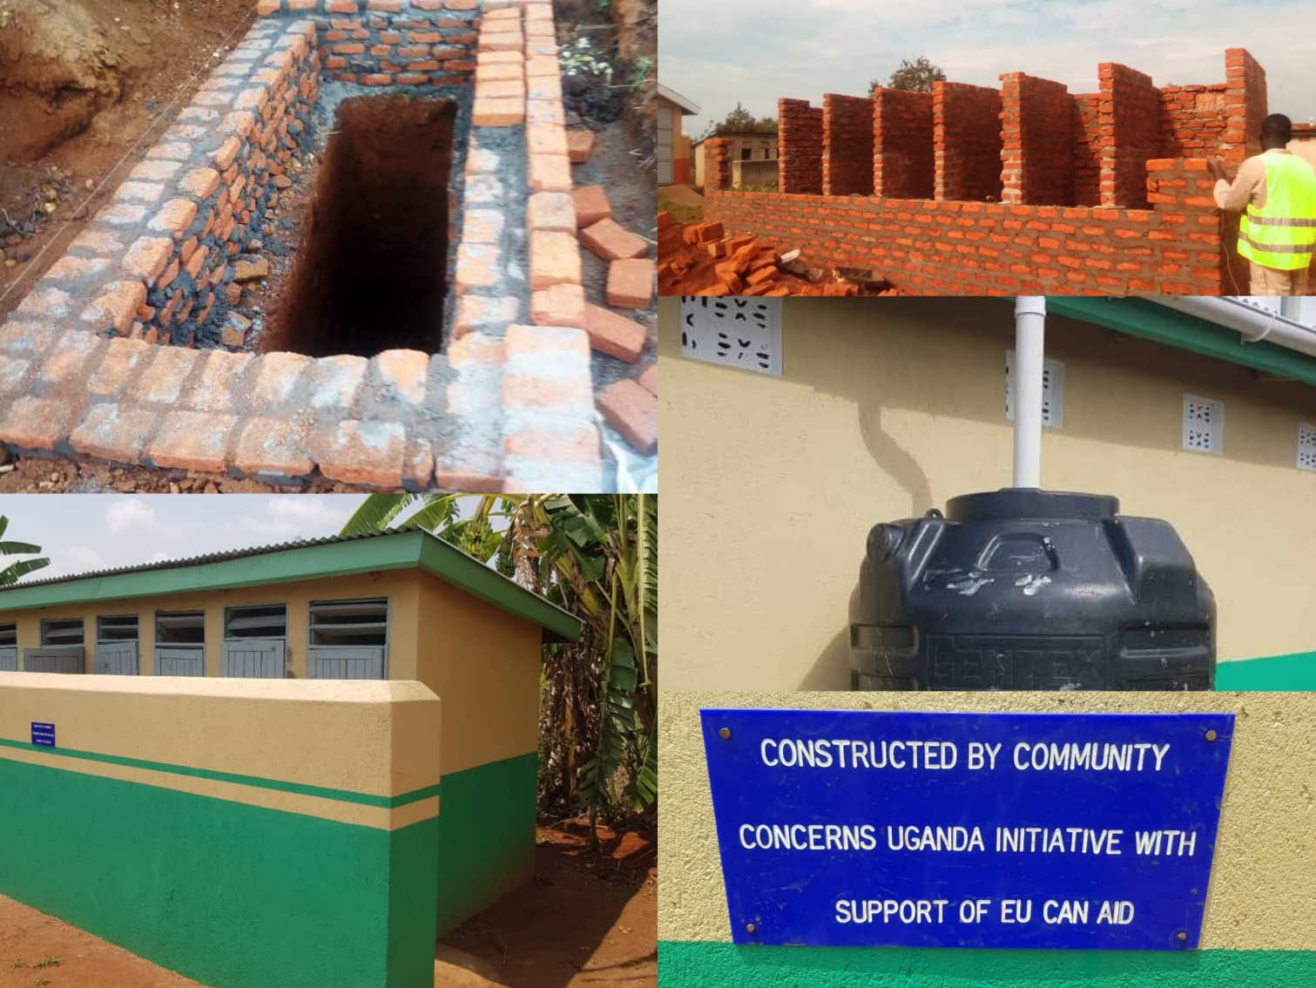

- We provided training to 10 Teachers, and PTA/SMC members on WASH using the Ministry of Education and Sports recommended Three-Stars-Approach. The training also covered integrating WASH information into learning and life-skills development. In addition, school administrators and PTA/SMC members were also trained in resource mobilization to build their capacity to mobilize, account for and monitor WASH-related needs of their schools. The training included;
Types of resources (financial and non-financial)
Resource mobilization according to the school mandate (vision, mission and objectives)
Functions of the school PTA/SMC related to resource mobilization
Challenges to resource mobilization in primary schools
Improving PTA/SMC functioning to undertake resource mobilization for WASH-related needs.
Approaches and actions to strengthen local resource mobilization by PTA/SMC.
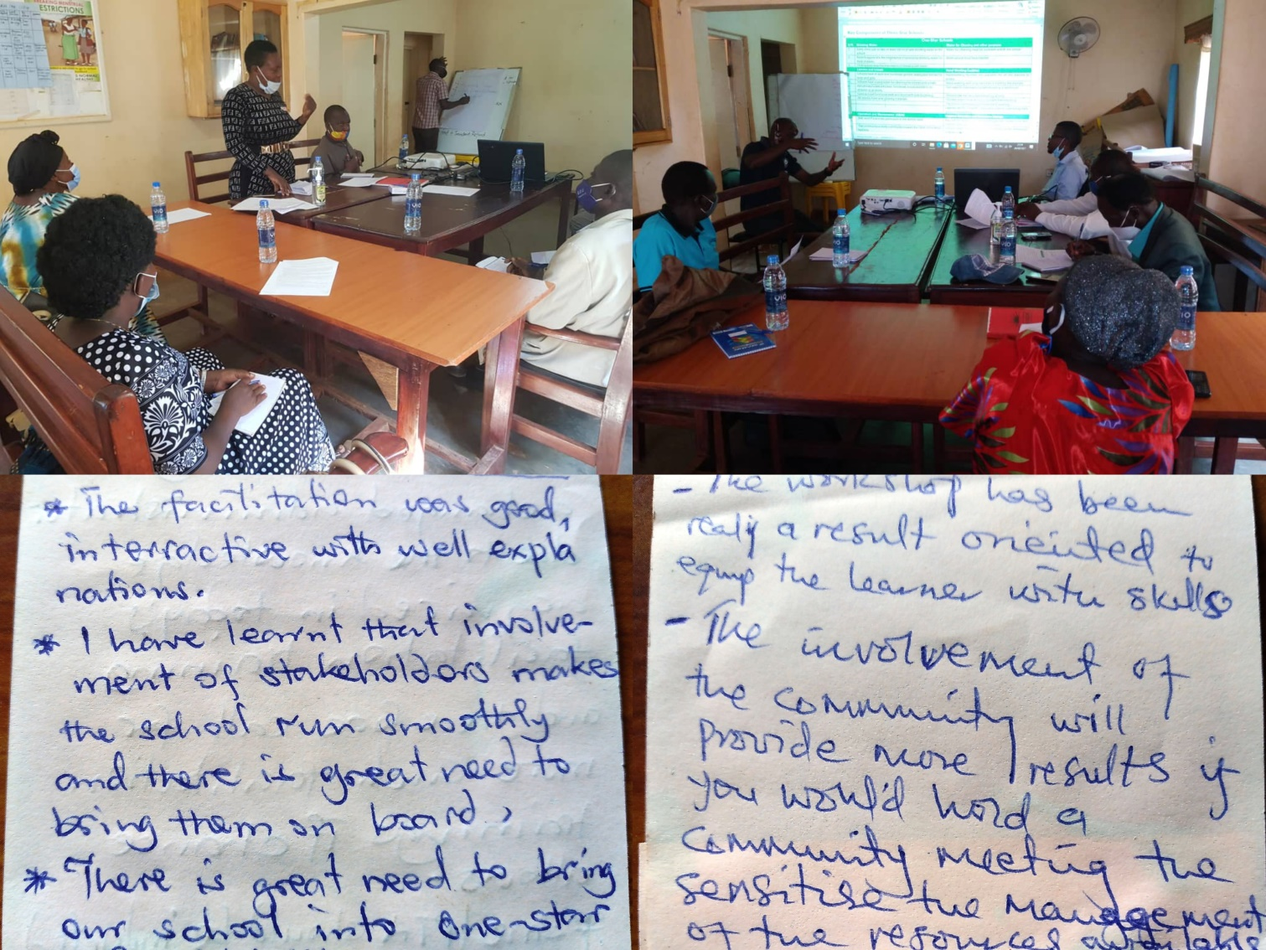

Challenges
- The long school closure due to COVID-19-induced measures, which started in April 2020 and ended in January 2022, affected the implementation of some activities. There were major delays in conducting the baseline survey
- During the pit latrine construction in Wabulungu, the selected site had a hard rock substrate that needed more time to drill and breakthrough. This slightly increased the amount of time and money spent digging the pit, delaying the construction of the latrines.
- During the capacity-building sessions among teachers, school administrators, and SMC/PTA members, most participants often came late which delayed the start of the training.
- Although both schools have established governance structures, their functionality is greatly impaired due to the inability of the members to perform their roles and responsibilities. From the training, we identified that a significant number of PTA/SMC members have limited knowledge of what roles they are to play in undertaking resource mobilization for their schools. Apart from that, participants reported not being inducted into their positions, having no guidance document (school governance manual/handbook) to provide direction, and lacking basic information about their schools, such as the school’s vision, mission, and objectives.

Lessons Learnt
- There is need to enhance the functionality of governance structures of primary schools to provide support, supervise, monitor and undertake resource mobilization to address identified WASH issues.
- While working with government-aided schools, it is very important to work with the local government at the district level to understand planned support to identified schools with the goal of reducing potential duplication of effort and determining how the district can best support the sustainability of WASH facilities.
Stories of Change
Story 1: SMC Member, Wabulungu Primary School

“Before the training, I was not actively participating in budgeting, especially for WASH. Now I know that it is my responsibility to participate in budgeting and discuss allocations. I had heard about the issue of poor menstrual hygiene in our school before from the SWT, but I did not know that I was in a position that could enable me to make positive changes for girls through budget allocations. I am also more aware of my role in monitoring school activities and have already done some visits to see how the school WASH facilities and activities are being managed. I think that training was an eye-opener to all of us (PTA/SMC) members.”
Story II: SMC Member, Mugeya Primary School

“… you have given our learners freedom…the freedom to select which stance to go to, it might seem small, but they never had such an opportunity as they frequently queued up to use 2 stances—which were not even ours. Some would go to the bush, but now they have the privacy, they can now ease themselves whenever they like, in a safe place that provides them privacy Menstrual Health and Hygiene (MHH)
MHHM
CCUg partnered with One Heart Uganda Charter and Uganda Community Based Association for Women and Children Welfare (UCOBAC) from Bugiri District to celebrate Menstrual Hygiene Day on 28th May 2021. The celebration, which was graced by the Inspector of Schools-Bugiri and involved 4 primary schools, attracted more than 400 pupils, 30 teachers and 50 community members. The participating primary schools included Buwuni, Namaselo, Nakigunju and Cornerstone Child Development Initiative, all from Bugiri district.

Achievements
- Trained 100 pupils and 15 teachers in re-usable pad production.
- Provided health education on MHH with emphasis on menstrual hygiene, pain management, stigma associated with menstruation, and why men/boys should be involved in menstrual health.

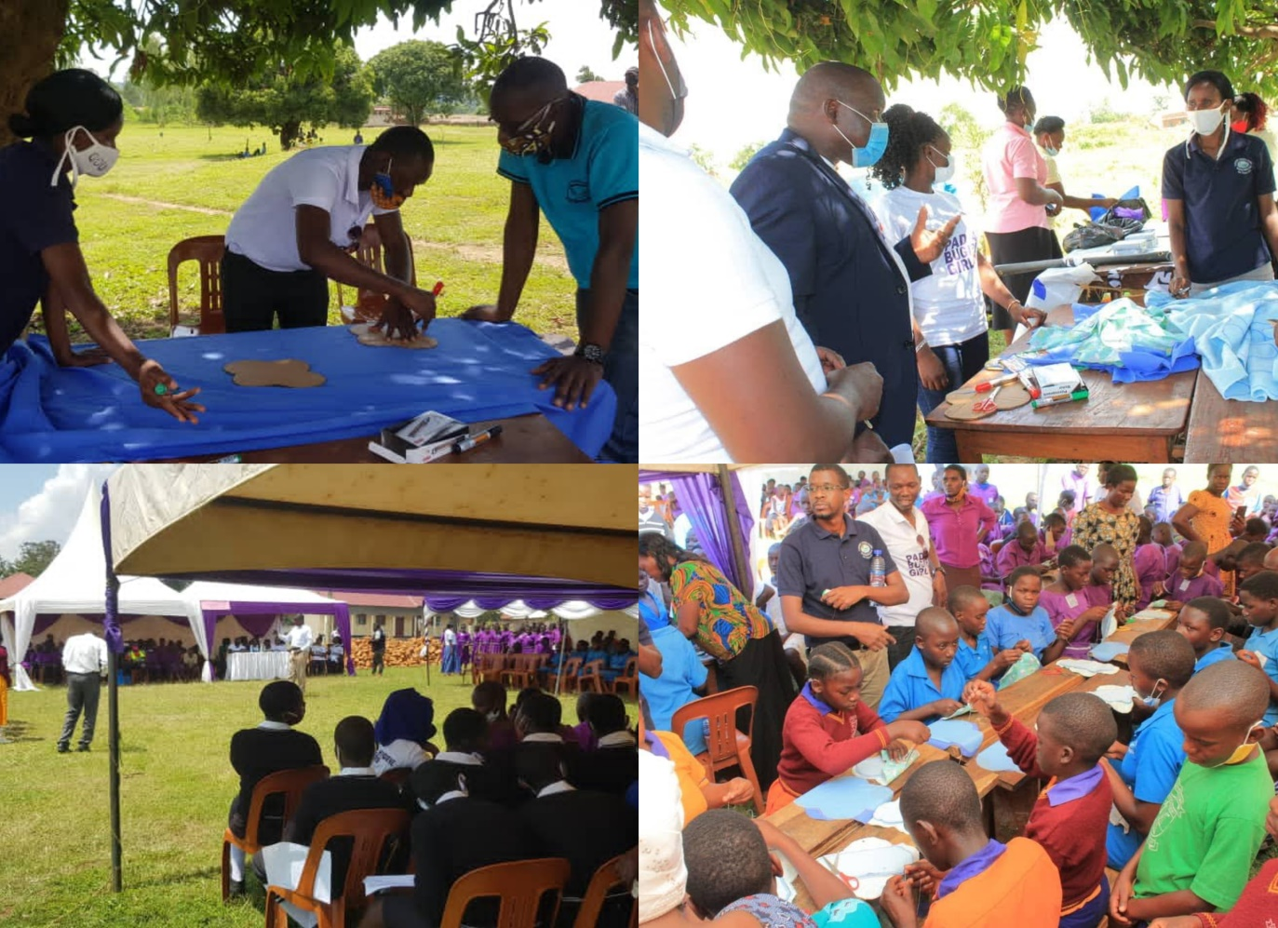

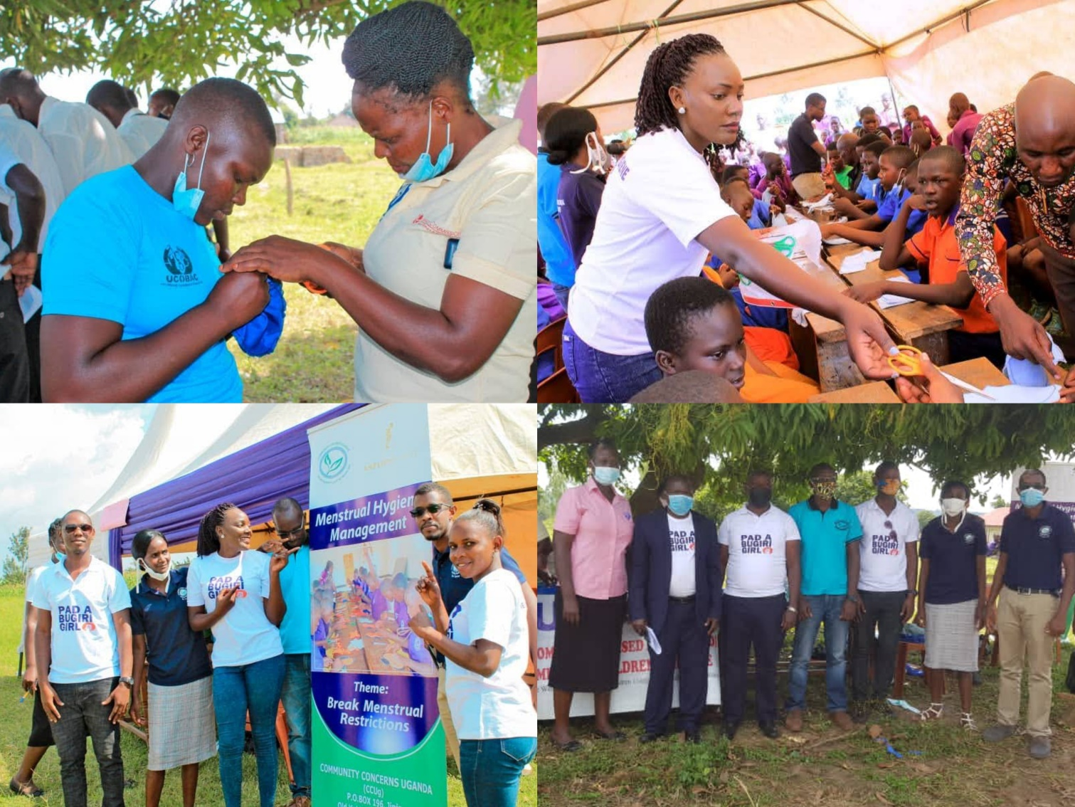

Challenges
- We were overwhelmed by the number of pupils who wanted to be trained in relation to the planned number. Although we procured materials to train 75 pupils, we ended up training 100. In addition, hundreds of adolescent girls and women from the community wanted to participate in the training even though we were restricted by lack of adequate materials.
Lessons Learnt
- Collaborations between like-minded NGOs with similar objectives strengthen service delivery and create long-lasting partnerships.

Raising Voices against Sexual Violence
Funded by AmplifyChange, this project sought to generate evidence relating to Sexual Violence (SV) while strengthening the ability of students, teachers/school administrators, PTA/SMC members to use the evidence to advocate for schools free of sexual violence.

Achievements
- Conducted a study on sexual violence among 12-19-year-old adolescents in 25 schools in 5 districts in the Busoga sub-region. The study included 2,730 adolescents from Jinja, Mayuge, Kamuli, Luuka and Buyende. Pertinent findings of the study are:
4 out of every 10 school-going adolescents reported having experienced at least one incident of sexual violence in the past year. Among these, 46.9% were girls and 31.8% were boys.
The commonest forms of SV included unwanted sexual touches (20.2%), unwanted love/marriage requests (14.6%), defilement (7.6%), forced kissing (4%), attempted rape (2.8%), sexual exploitation (2.1%), forced marriage (1.7%), rape (1.6%), sex for marks (1.3%) and incest (1%).
Among the 5 districts, Mayuge had the highest overall rate of SV at 51.9%. Disaggregated by gender, Mayuge still had the highest rate of SV among girls at 70.9% while Luuka had the highest rate of SV among boys at 40.6%.
Adolescents in secondary schools experienced more SV at 42.6% as compared to their counterparts in primary school at 31.1%. Findings from secondary respondents suggested that schools document far fewer cases of SV than are actually experienced by adolescents, making it a common but underreported problem.
The major risk factors associated with SV included watching pornography, negative peer influence, multiple sexual partners, exposure to domestic violence, limited access to sexuality education, poor law enforcement, unsafe school and home environments, and harmful beliefs/actions that perpetuate and normalize sexual violence.
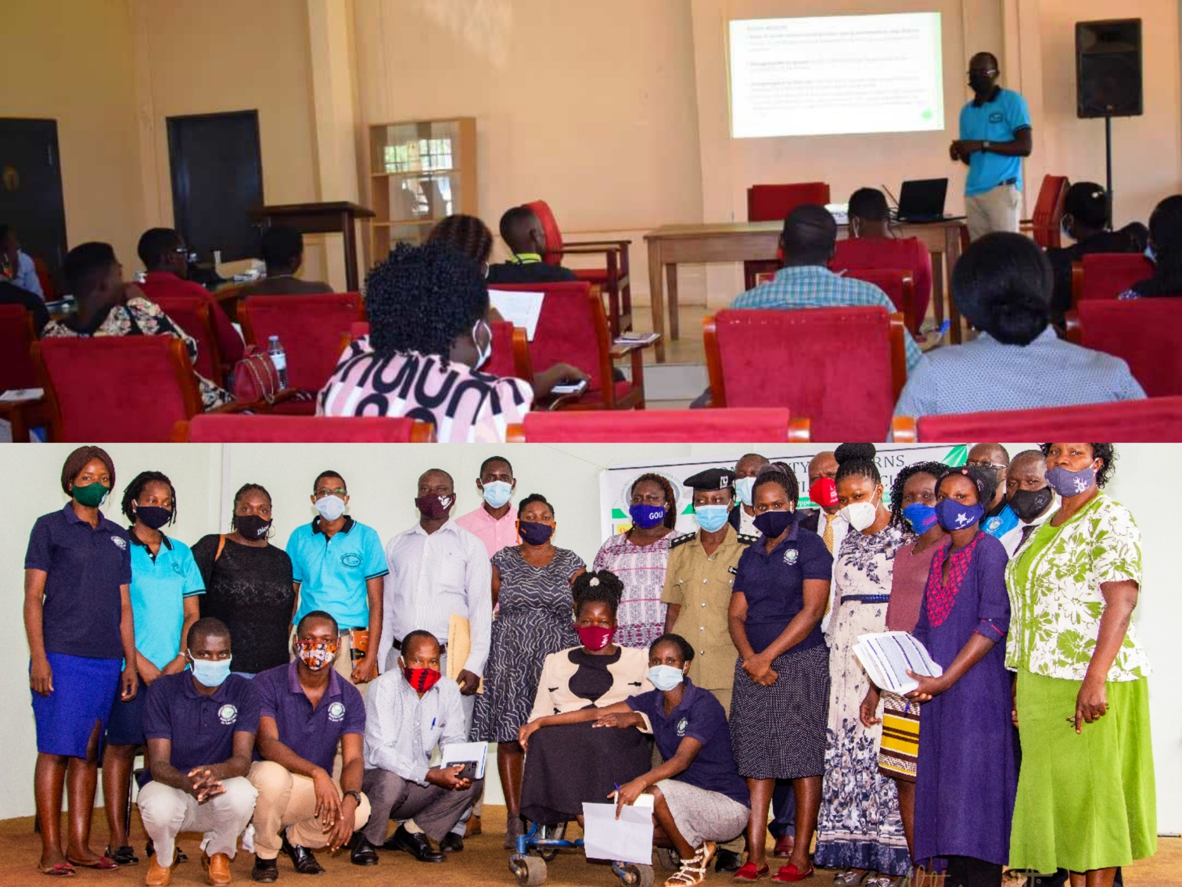
- Disseminated study findings to different stakeholders;
Through a dissemination seminar, we disseminated the findings to 42 key stakeholders including district education officials (District Education Officers and School Inspectors), probation and social welfare officers, school administrators, teachers, local leaders, and students. Following this dissemination, findings were later disseminated to the public through two national TV stations—NBS and Baaba TVs.
Together with MUCOBADI—a local NGO, we conducted 2 engagement meetings with district education and community development officers of Mayuge and Jinja districts. Apart from validating the study findings attributing the high rates of SV to closure of schools, district education officials from Mayuge committed themselves to train teachers about SV and the Ministry of Education and Sports’ recommended reporting guidelines. Officials from Jinja district committed themselves to conduct more school inspections to stamp out SV while supporting teachers who report cases involving their superiors.
CCUg was invited to present to participants at the 2021 Jinja District Budget Conference. The aim of the presentation was to provide evidence on SV to inform policy makers to allocate adequate resources towards addressing it among adolescents.
- Trained 25 teachers and school administrators about sexual violence and advocacy. The training covered:
Sexual Violence: forms, predisposing factors, effects, manifestations, legal framework, challenges to reporting, and Reporting Tracking, Referral and Response (RTRR) guidelines.
Advocacy: definition and the benefits of advocating for violence-free schools, identification of a problem related to SV for advocacy, channels of advocacy and how teachers can actively participate in advocacy.
- Training 32 student advocates (students and teachers—Senior Woman Teacher and Senior Man Teacher) on the basics of advocacy. The training covered:
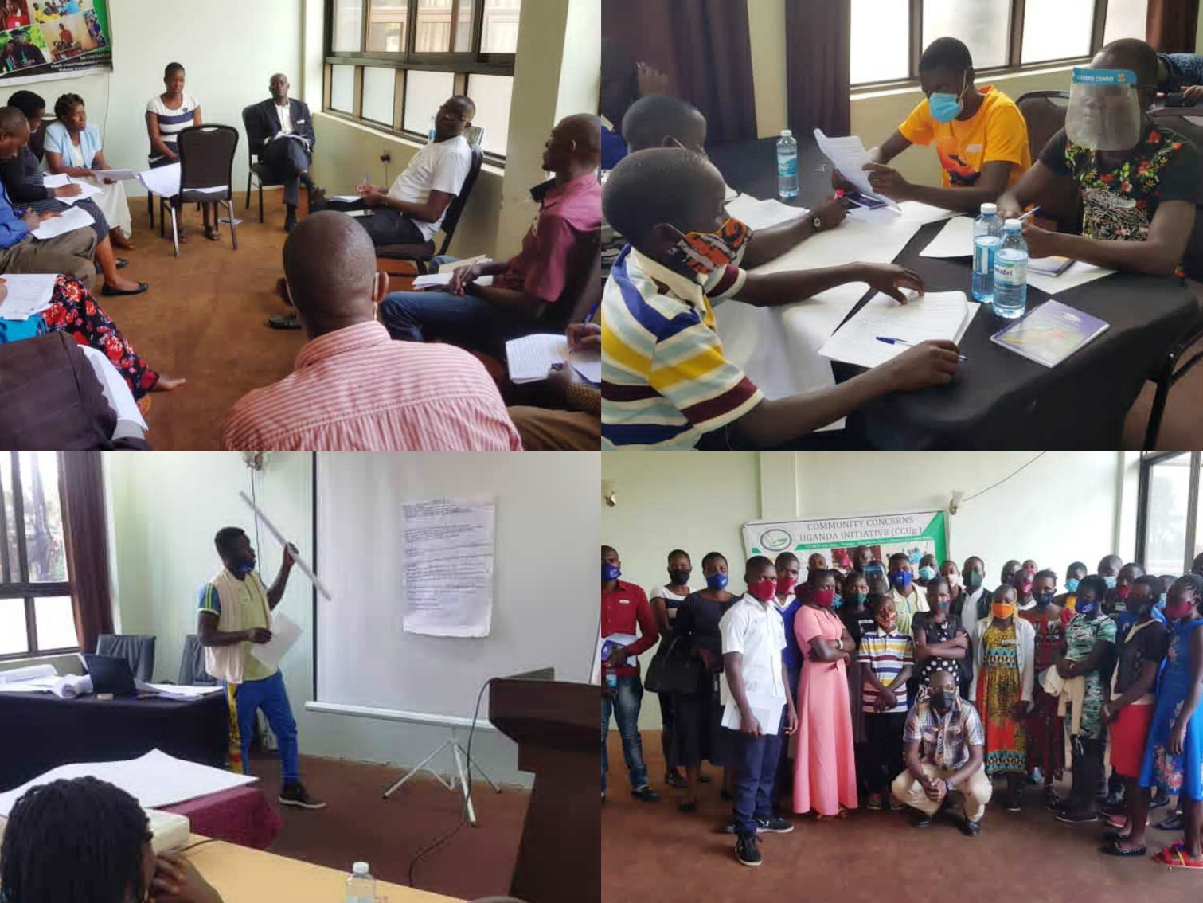
The importance of students advocating for violence-free schools, introduction to SV, analyzing a problem related to SV for advocacy, designing an advocacy plan, identifying the target audience and advocacy activities, developing advocacy messages, monitoring and evaluation.

- Conducted 12 radio talk shows on SV and reached 26,381 listeners from the Busoga sub-region, parts of Kalangala Island, and Buikwe district. The talk shows involved trained youth advocates, parents, teachers, probation and social welfare officers, community development officers, and youth counselor. The major themes covered during the talk shows include d:
Sexual Violence (SV) among adolescents; rates, predisposing factors and ways of addressing it as per survey data.
Role of Senior Female/Male Teachers (SF/MT) in addressing SV in schools.
Role of adolescents in addressing SV
Teacher-student sex/relationship in Busoga Sub region
Poor menstrual hygiene management and sexual violence
Exposure to domestic violence and sexual violence in the Busoga sub region.
Sexuality education and sexual violence.
Sexual violence reporting and legal penalties.
Harmful beliefs and norms that sustain sexual violence and bystander prevention.
Life skills and sexual violence.
Role of teachers and parents in addressing sexual violence
Student-teacher sexual relationships
School re-entry for adolescent mothers.

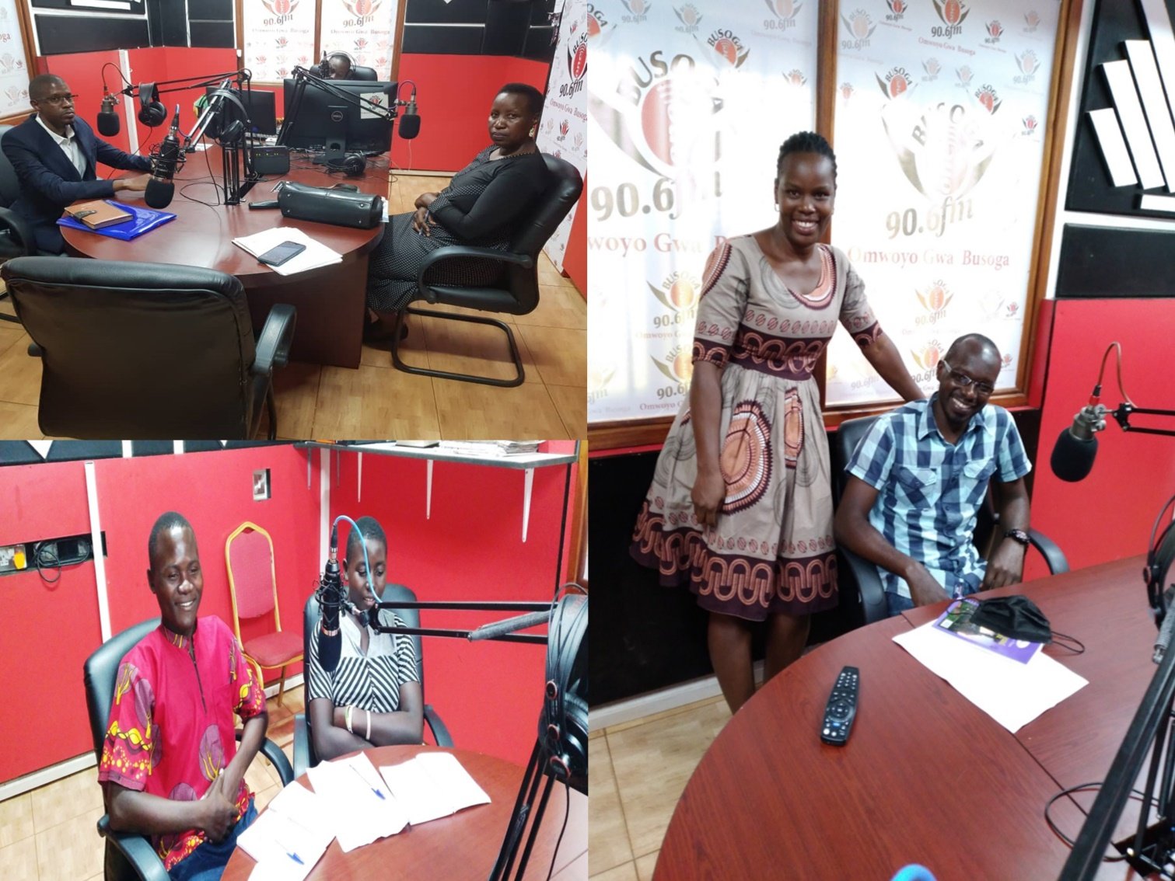

- A music workshop was held among selected choir members of participating schools. A joint song was composed and produced on sexual violence. The final copy of the song “entitled Tugalaga abaana” features local artists from Jinja.
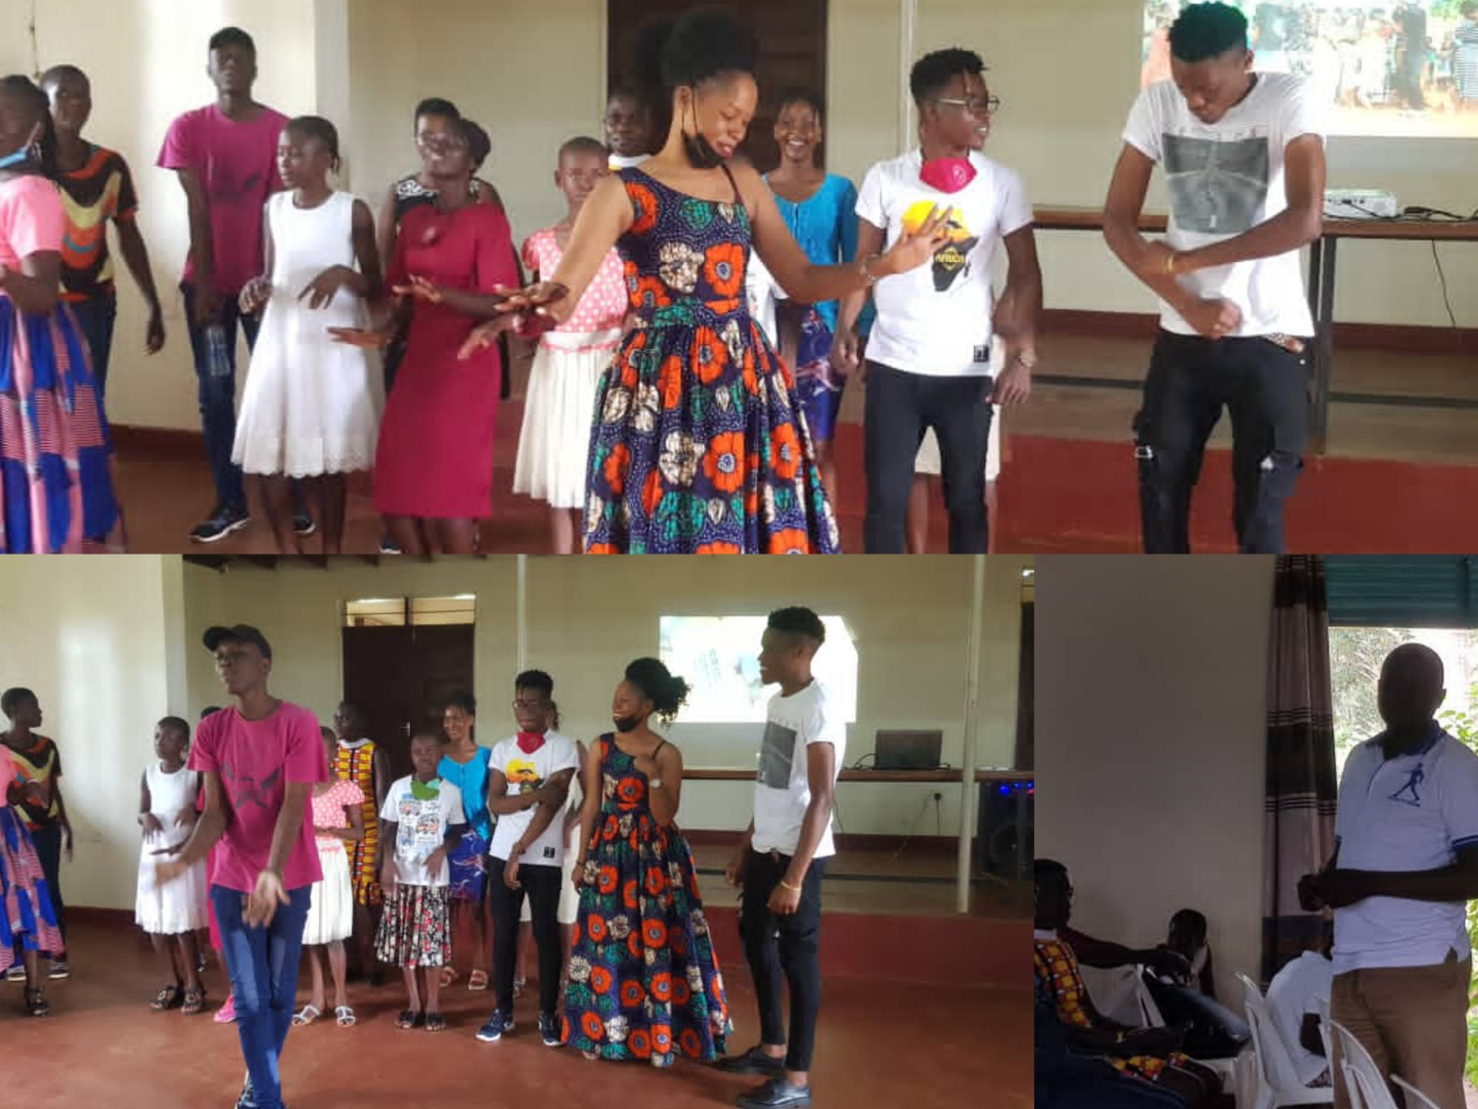
Challenges
- The project experienced delays related to data collection. Due to COVID-19 restrictions, there were delays in obtaining Institutional Review Board (IRB) and Ugandan National Council for Science and Technology permission to conduct the study. Even when the permission was provided by the IRB, closure of their offices due to COVID-19 restrictions delayed accessing the permission letter for over 3 weeks. This led to a delay in the initiation of the data collection. Even after data collection, the 42-day national lockdown hindered the dissemination exercise, contributing to further delays of other activities
- Furthermore, the project was designed concentrating on schools as focal centers of evidence-generation and implementation. However, the closure of schools due to COVID-19 led to re-structuring the project as a school-community based project. Public transport restrictions led to overspending on evidence-generation. Other added costs related to the COVID-19 pandemic included procurement of face masks for all respondents, and building institutional capacity to work from home during the lockdown. This led to reducing the scope of some activities, while others were cancelled.

Lessons Learnt
- Involving key district officials in the planning and implementation of the project was very vital in highlighting the need for addressing sexual violence among adolescents. Although we faced severe opposition during the data collection, district officials were supportive and understood the cause of the opposition.
- To promote utilization of study findings at district level, it is important to include district officials in the design and implementation of the study. Concerted efforts should be made to include them at all planning levels to increase ownership and subsequent utilization.
Story of Change I
Muzafaru—Senior Three, 18 years, Kaluuba High School, Mayuge
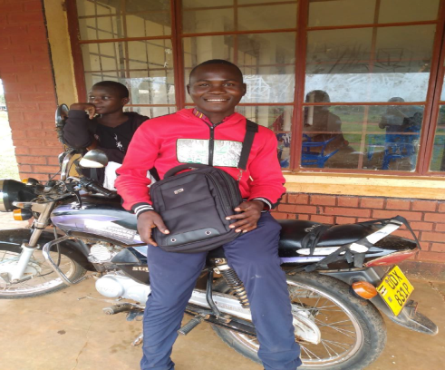

“During the last lockdown in May this year, my young sister got pregnant, she is only 16. My father was devastated and I was very disappointed. I come from a poor rural family in Kaluba Village, Mayuge district. I was very angry about what happened…I had high hopes for her but now things changed. My father sent her away from home to stay with another relative, but she ran away 3 days later to start marriage to her 22-year-old boyfriend. When I was selected for training as a youth advocate, it gave me the opportunity to speak out against something dear to me. I had just seen the impact of sexual violence in our family and through the training, I learned how to speak out for issues concerning us—the youth.

I had known about sexual violence before but I did not know that its magnitude was very huge. I also learned that when I see someone being abused, I need to take action and even report, to my parents, the LC, or even the police. I must speak out against violations of others…

There are things that I used to do that I stopped after realizing their negative effect. I had many sexual partners, but I had to stop the relationships. There are more dangers from having multiple partners than what I used to gain. At the moment, my goal is to positively influence other youths in my village. I have taught my 10 friends about sexual violence; forms, effects, and what to do when one does it. Some of them told me that it is hard to control their sexual urges, but I have told them that they need to think about their future. Whenever they get that urge, I tell them to reflect on the impact of experimenting; something that does not even take 10 minutes may affect you for the rest of your life.

I am very happy that Community Concerns allowed me to teach other young people over the radio. Many of my friends listened to the show; my father was very happy and felt proud of me, he knows that the path I took will lead to a better life. I met district education officials and counselors of Mayuge district. We told them our concerns and the education officials promised to take action next year to address sexual violence in schools. I hope they live up to their words.

Furthermore, I hope we can continue reaching out to more young people, especially those who might miss listening to the radio through dialogues. We need to bring young people together to discuss issues that affect them at the village level, I am certain, we shall see change.”

Story of Change II
Deborah—15 years, Senior Three St. John S.S.S Buwaya, Mayuge
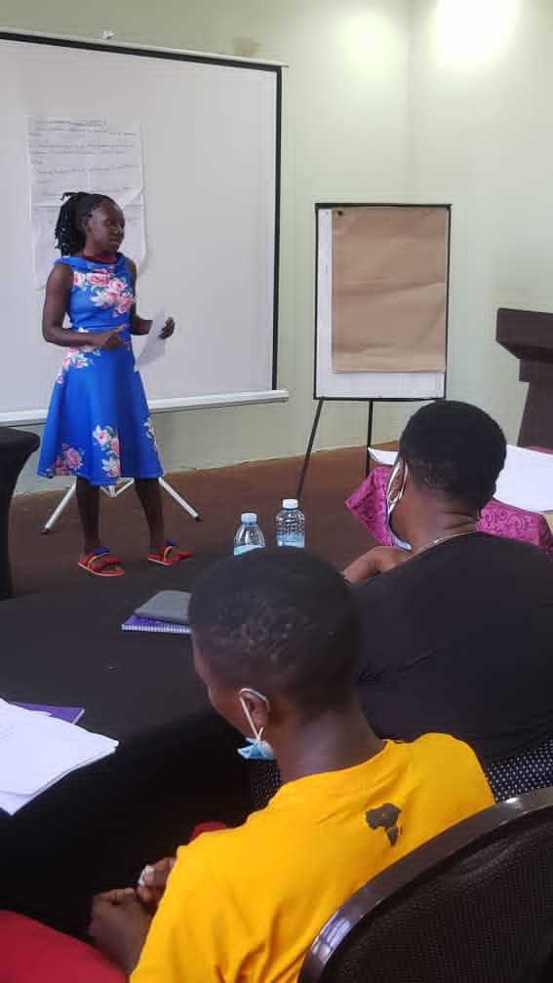
“When the LC I chairman of our village got to know that I had been trained about sexual violence, he was very happy. Over the past 2 weeks, he has been speaking to parents of adolescent girls, especially those at risk of experiencing violence, directing them to me to teach them about violence. Nearly every day, I can speak to between 4 to 10 girls. I always teach them the forms of sexual violence, what to do to prevent it, how and where to report it.
I am grateful for the opportunity that Community Concerns provided me to be trained as a youth advocate. Personally, the training helped me to understand how to communicate better, especially when saying no to unwanted sexual advances. I learned that when I say no, I should stick to it and not only say no but also engage in actions that indicate that I am not interested. I also learnt how and where I can report.

While working with the LC I, I have realized that in our village, some adolescents are scared of reporting cases of violence due to shame associated with it; some are scared of what the perpetrator will do…while others do not know where to report. So, I have taught my fellow adolescent girls ways of preventing themselves from sexual violence. I have also taught them what to do in case they are violated and where to seek support.

I do this on a one-on-one basis (based on the LC recommendations) and other times, I speak with girls in groups. Last week, I came across a case of child abuse and neglect. One of our neighbour’s children… She is 14 years but looks after 3 children without any adult supervision. I also got to know that she was raped by one of the family members 2 months ago. So, I approached the LC and told him about this case. He spoke with the parents of this girl and there is now an adult supervisor. I also worked with the LC I to report this other case of rape. I hope to follow up on the case and see what happens.

I think Community Concerns should train more girls like me to teach other girls how to prevent and report sexual violence. So far, my biggest challenge is that I lack counseling skills. Some of the girls I speak to need an adult counselor to provide psychosocial support. I also suggest that the organization should provide T-Shirts to its youth advocates so that we can be easily identified in the villages. I like what I am doing and I know that it will bear fruits.”

LIVELIHOOD

Group Savings Project
Like a Village Saving and Loan Association (VSLA), the GSP is comprised of 10- 50 individuals (mainly women) living in the same villages, who are known to each other and who regularly meet to save and acquire loans from their pooled savings, which provides a means of earned interest on member savings. At the beginning of each saving year, each group agrees on specific interest rate to be applied to loans in the coming year. CCUg has a stake in each group, as we occasionally inject money into these groups to meet their credit requirements. The CCUg GSP has grown in terms of the number of members, the amounts saved, the value of loans financed, the interest earned and number of groups in operation.

Activities/Achievements
- The Group Saving Project grew in numbers from 335 members to 419 members.
- Fifteen women from Ntinkalu village belonging to Mununuzi Group were trained in financial literacy and business management. The training enhanced their business skills management, and taught them how to calculate profits and how to best sustain their businesses by minimizing risk factors for failure.
- Personal business assessment was conducted among 15 women in Ntinkalu village after training them in Financial Literacy. This involved conducting a feasibility assessment and the resources needed to undertake selected businesses. The assessment also entailed a projection as to the profitability and sustainability of the proposed businesses.
- The groups added 84 more members; Nakalanga had 90 members in2 020 and grew to 95 members by end of 2021, Magamaga group had 36 members in 2020 and grew to 51, Wairaka group had 52 members and grew to 60 members, Wabulungu group increased to 43 members from 26, Mauta increased to 51 from 36, Bugodi increased to 20 from 19 and Bukoli increased from 17 to 25.
- One more group was created which is Mununuzi from Ntinkalu village
- Compared to 2020, there was a great improvement among the 11 groups as regards to savings and interest earned, as shown in the table below.
- CCUg made a capital injection (start-up capital) of 1,200,000/= into the Mununuzi savings group to start the program, which includes 14 members. Our target group for the start-up capital was those members whom we enrolled into our Interpersonal Group Therapy program and were having little or no access to financial services.

Challenges
- Time management continues to be a concern. During the financial literacy and business management training sessions, some of the group members came late, which delayed the start of the session.
- The fact that some group members speak Swahili and langi languages as their mother tongue is a challenge, as it takes more time to explain the concepts and make the points clear to participants.
- Covid -19 pandemic affected the groups because their finances reduced due to lockdown
Growth Trend of GSP Members from 2019 to 2021

Growth Trend of GSP Savings, Loans and Interest – 2019 to 2021
2020 2021

Group | 2020 Savings | 2021 Savings | % Increase
Nakalanga (total) | 54,761,500 | 45,647,400 | -17
Magamaga | 19,959,000 | 27,028,000 | 35
Mauta | 10,707,600 | 21,222,700 | 152
Wairaka | 17,715,000 | 29,883,000 | 69
Wabulungu | 3,214,000 | 8,758,300 | 172
Bukoli | 2,900,000 | 4,829,600 | 66
Bugodi | 1,859,700 | 3,101,000 | 66
Kyebajjatobonna | 1,501,500 | 8,128,600 | 441
Basekamajja | 1,915,400 | 5,629,200 | 193

- The 11 groups received a return of their savings with accumulated interest throughout the year totaling Ugx 18,747,900. Of these, Magamaga group earned the lion’s share with Ugx 4,333,800 followed by Wairaka at Ugx 3,456,300, Mauta at Ugx 3,248,700, Nakalanga 2 at Ugx 1,816,600, Kyebajjatobona at Ugx 1,558,700, Nakalanga 1 Group at 1,310,800, Wabulungu at Ugx 1,143,400, Bakusekamajja at Ugx 840,400, Bukoli at 378,400, and Bugodi at Ugx 209,500.
- The interest on their savings has increased due to an increase in the loans taken.

Challenges
- Poor weather conditions affected the crop yield, especially for Nakalanga, and they made loss.
- Late arrivals for the GSP meetings continue to be a major challenge.
- Some members are not reaching the threshold set for savings due to limited capital available from their businesses. This causes them to accumulate fines and in the end, they earn little.
- Loan payment for some groups was poor due to the losses incurred.

INCOME-GENERATING ACTIVITIES
Watermelon growing was a new infrastructure project that we began in Q1. The vision was to first establish this agribusiness as a means of providing a stable source of income to support the ongoing projects and programs of the organization that are not funded by grants and designated charitable contributions, including OVC Sponsorship, Group Savings Programs, Adult Literacy and ongoing Sexual and Reproductive Health and Rights (SRHR) and Menstrual Health Management (MHM) training in local primary and secondary schools.

Activities/Achievements
- Researched opportunities for a stable source of funding for ongoing projects and identified watermelon farming as a viable option. Performed a cost-benefit analysis based on projected expenditures and estimated earnings to determine the number of acres needed to provide funds to cover the annual program costs of our ongoing programs.
- CCUg management and staff received training in Watermelon growing by Farm Solutions Africa, which equipped us with the information and skills needed to manage the watermelon gardens.
- Researched and rented land for growing watermelon.
- We planted seventeen acres of watermelon.

Challenges
- Poor weather conditions adversely affected the viability of the crop.
- COVID- 19 lockdown affected our market to sell the watermelon.

OVERALL LESSONS LEARNT IN 2021
- Working together as a team enables great achievements and resource mobilization. It is important to work as a team because that enables greater impact and brings different ideas to bear in solving problems.
- Radio-based messaging reaches many people from different areas. Many people learn from such programs and this impacts their lives positively.
- Vocational skills are effective in improving the employability of young women with low educational levels. However, students need frequent encouragement and follow-up to complete classes due to the several challenges they experience.
- With respect to vocational skilling programs and adult literacy, instructors need to employ a more patient and slow approach for participants to these courses, who join after being out of school for a long time, as they tend to be slow at learning.

Overall Recommendations
- Capacity building training for various projects that require proposal writing should be kept at the forefront. This will help staff continuously learn new and better skills of fundraising for the organization to improve sustainability.
- Talk shows reach a large number of people from different areas, and we should incorporate more of these into our projects.
- Provide business resilience training during emergencies and introduce an emergency fund that members can borrow from so to preserve their own capital in such situations.
- Continue to work within the communities we serve to explain the value of being on time for appointments and encourage them to do so.
- Self-esteem should be inculcated into pupils and students in our efforts to combat school-related gender-based violence. Most students are still afraid to talk about gender violence; they need to be encouraged to “Get Up and Speak Up”.
- School administration officials should be reminded of the impacts of MHHM and SRGBV on academic performance; these concerns impact not only the reputation and academic success of the school but also of the pupils/students. This kind of advocacy will encourage school officials to prioritize these programs and make a greater commitment to them.
- Mobilize financial resources (capital injection) for GSP groups to allow them to expand on their businesses and to start up new businesses for those who don’t already have one.

FINANCIAL REPORT FOR 2021

INCOME FOR THE YEAR ENDING 31 DECEMBER 2021

EXPENDITURE FOR THE YEAR ENDING 31 DECEMBER 2021

